|  |  |  |  |  |
| --- | --- | --- | --- | --- |
| **Agri-food Policy**  Sustainable Agri-food Development Division  Food and Farming Group | | | |  |
|  |  |  | Sustainable Agri-food Development Division  Clare House 303 Airport Road West  Sydenham Intake  Belfast  BT3 9ED Email: [marketing.standards@daera-ni.gov.uk](mailto:marketing.standards@daera-ni.gov.uk) | | |

07 May 2024

Dear Stakeholder,

**DRAFT HOPS (AMENDMENT) REGULATIONS (NORTHERN IRELAND) 2024**

I am writing to invite your views on draft legislation, the Hops (Amendment) Regulations (Northern Ireland) 2024. The draft Regulations amend the previous regulations The Hops Certification Regulations 1979 as they apply here, primarily to provide enforcement powers for updated EU rules on hops certification and hops imports from third countries which are directly applicable in Northern Ireland.

As the legislation relates to food, this engagement is being carried out as required by [Article 9 of Regulation (EC) No. 178/2002](https://www.legislation.gov.uk/eur/2002/178/contents), laying down the general principles and requirements of food law. The Department is engaging now to ensure stakeholder views are recognised early in the legislative process.

**Background**

European Union marketing standards for agri-food products establish definitions, minimum product standards, production methods, sales descriptions, product categories and labelling requirements. They apply at all stages of the marketing chain and are intended to protect consumers and to facilitate the trade of applicable goods on the single market. The standards are set out primarily in [EU Regulation 1308/2013](https://eur-lex.europa.eu/legal-content/EN/TXT/?uri=CELEX%3A02013R1308-20231208), commonly referred to as the Common Market Organisation (CMO) Regulation and associated delegated and implementing regulations.

Since December 2006, the certification of hops and hops products has been regulated in the EU by [Regulation (EC) 1850/2006](https://eur-lex.europa.eu/legal-content/EN/TXT/?uri=CELEX%3A02006R1850-20130701). Since December 2008, third country hop imports has been regulated by [Regulation 1295/2008](https://eur-lex.europa.eu/legal-content/EN/TXT/?uri=CELEX%3A02008R1295-20220506). Domestically hops certification is enforced by the Hops Certification Regulations 1979, which covers both hops certification and importing hops from third countries.

On 07 March 2024, The European Commission published new delegated and implementing regulations for hops certification in the Official Journal. These regulations entered into force on 27 March 2024 and repealed 1850/2006

* [Commission Implementing Regulation (EU) 2024/601](https://eur-lex.europa.eu/eli/reg_impl/2024/601/oj) laying down rules for the application of Regulation (EU) No 1308/2013 of the European Parliament and of the Council as regards the certification of hops and hop products and related controls
* [Commission Delegated Regulation (EU) 2024/602](https://eur-lex.europa.eu/legal-content/EN/TXT/?uri=CELEX%3A32024R0602&qid=1709909493245) supplementing Regulation (EU) No 1308/2013 of the European Parliament and of the Council as regards the marketing standards in the hop sector and repealing Commission Regulation (EC) No 1850/2006.

On 21 December 2023, the European Commission published new regulations for the import of rice, cereal, sugar and hops from third countries in the Official Journal. These regulations entered into force on 28 December 2023 and replaced and revoked 1295/2008.

* [Commission Implementing Regulation (EU) 2023/2834](https://eur-lex.europa.eu/legal-content/EN/TXT/?uri=OJ:L_202302834#ntr15-L_202302834EN.000101-E0015) laying down rules for the application of Regulation (EU) No 1308/2013 of the European Parliament and of the Council as regards imports in the sectors of rice, cereals, sugar and hops
* [Commission Delegated Regulation (EU) 2023/2835](https://eur-lex.europa.eu/eli/reg/2023/02835/oj) of 10 October 2023 supplementing Regulation (EU) No 1308/2013 of the European Parliament and of the Council as regards rules on import in the sectors of rice, cereals, sugar and hops, and repealing Commission Regulations (EC) No 1295/2008 amongst others

**The draft Hops (Amendment) Regulations (Northern Ireland) 2024**

EU hops legislation relating to third country imports and certification are directly applicable in Northern Ireland under Annex 2 of the Windsor Framework. As the EU regulations are being repealed and replaced, the Hops Certification Regulations 1979, require updating amendments. **The draft Regulations are attached at Annex A.**

**Stakeholder views**

While many of the changes to the EU regulations are technical in nature, and all but one of the changes are automatically directly applicable in NI, the Department is seeking any stakeholder views on the draft amendments to the NI implementing regulations. **The changes are outlined at Annex B.** The draft Regulations seek to replicate the current hops regulations as far as possible by simply updating references to the legislation and updating the enforcement powers to enable enforcement of the updated EU regulations. The draft Regulations do not represent a change in the underlying policy.

**The Department would welcome any comments you have on the draft Regulations at Annex A, noting the key changes highlighted in Annex B.** **The Department is specifically seeking stakeholder views on the option to make use of the EU derogation to ensure that the costs of certification are not borne by the operators subject to it. Use of this derogation will allow the continuation of current practices in the UK.** Please feel free to bring this to the attention of any other stakeholders who you think may have an interest.

**Equality and Rural Needs**

The draft Regulations have been considered for their impacts on equality and human rights, and have been screened out of the need for a full Equality Impact Assessment on the basis that they do not have any equality or human rights implications. A Rural Needs Impact Assessment has been carried out which has concluded that there is no differential impact upon citizens in rural areas. The Department welcomes any comments or evidence in relation to the Department’s conclusions in this regard.

**Privacy, confidentiality, and access to consultation responses**

The Department takes data protection and the security of your personal data seriously. It takes care to ensure that any personal information received from you is dealt with in a way which complies with the requirements of the UK General Data Protection Regulation and the Data Protection Act (2018).

Your response, and all other responses to the consultation, may be disclosed on request. The Department can only refuse to disclose information in exceptional circumstances. Before you submit your response, please read the paragraphs below on the confidentiality of consultations and they will give you guidance on the legal position about any information given by you in response to this consultation.

Section 8(e) of the Data Protection Act 2018 permits processing of personal data when necessary for an activity that supports or promotes democratic engagement. Information provided by respondents to this stakeholder engagement exercise will be held and used for the purposes of the administration of this current exercise and subsequently disposed of in accordance with the legislation. For more information and to view the DAERA Privacy Statement please go to: <https://www.daera-ni.gov.uk/publications/daera-privacy-statement-document>

The FOI Act gives the public a right of access to any information held by a public authority, namely, the Department in this case. This right of access to information includes information provided in response to a consultation. The Department cannot automatically consider as confidential, information supplied to it in response to a consultation. However, it does have the responsibility to decide whether any information provided by you in response to this consultation, including information about your identity should be made public or be treated as confidential. If you do not wish information about your identity to be made public please include an explanation in your response including any harm you believe such a disclosure might cause.

This means that information provided by you in response to the consultation is unlikely to be treated as confidential, except in very particular circumstances. The Lord Chancellor’s Code of Practice on the FOI Act provides that:

* The Department should only accept information from third parties in confidence if it is necessary to obtain that information in connection with the exercise of any of the Department’s functions and it would not otherwise be provided;
* The Department should not agree to hold information received from third parties “in confidence” which is not confidential in nature acceptance of which by the Department of confidentiality provisions must be for good reasons, capable of being justified to the Information Commissioner.

For further information about confidentiality of responses please contact the Information Commissioner’s Office or visit the [ICO Website](https://ico.org.uk/).

**Accessibility**

Copies of these documents can be made available, on request, in alternative formats e.g. in large print, Braille disc, audio cassette and other languages. Please contact us at [marketing.standards@daera-ni.gov.uk](mailto:marketing.standards@daera-ni.gov.uk), or 028 9037 8575, to arrange such copies. For those with hearing difficulties, please leave a message on the Department’s text phone (18001 028 9037 8575).

**Responding to the Department**

This letter, and associated documents, are available on the Department’s website at:

[www.daera-ni.gov.uk/consultations](http://www.daera-ni.gov.uk/consultations)

Comments on the draft Regulations, or on related issues as referred to above, can be sent to: [marketing.standards@daera-ni.gov.uk](mailto:marketing.standards@daera-ni.gov.uk)

**Please note that the closing date for comments is 5pm on 02 July 2024.**

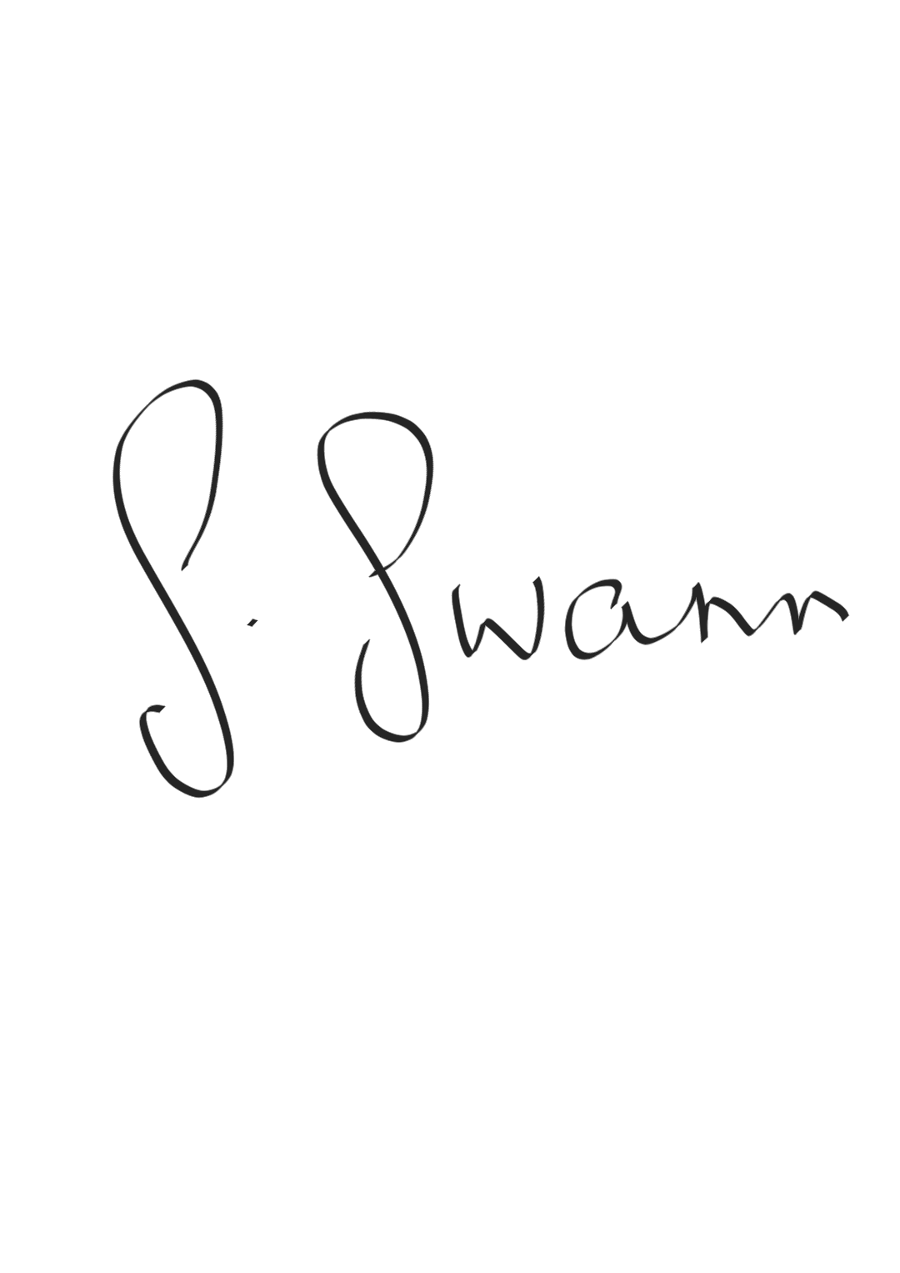

Yours sincerely,

**Samantha Swann**

**Agri-food policy**

**Sustainable Agri-food Development Division**

**Attachments:**

Annex A - Draft Hops (Amendments) Regulations (Northern Ireland) 2024

Annex B - Key changes to be enforced by the draft SR