Food and Farm Group  Sustainable Agri-Food Development |  |  | 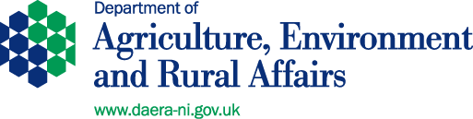
 | 05 November 2018  Dear Consultee, |  |  | Agri-Food Policy I  DAERA  Room 919, Dundonald House  Upper Newtownards Road  Ballymiscaw  Belfast BT4 3SB  Telephone: 028 9052 5459  farmpolicybranch@daera-ni.gov.uk

Consultation on Equine Identification (Horse Passports) in Northern Ireland
The Department of Agriculture, Environment and Rural Affairs (DAERA) is seeking views on its proposed approach to the implementation of the European Union Commission Implementing Regulation (EU) 2015/262 regarding the identification of equidae in Northern Ireland.
The consultation document is available at:
www.daera-ni.gov.uk/consultations/consultation-equine-identification-horse-passport-regulations-northern-ireland-2018
You may choose to comment on all or only some of the information included in the consultation. You may also submit additional comments. Any comments on the consultation should be sent to either the above postal or email address.
Copies of the consultation document can also be made available, on request, in alternative formats e.g. in large print, Braille disc, audio cassette and other languages. Please contact me on 028 9052 5459 or, for those with hearing difficulties, leave a message on the Department’s text phone (18001 028 9052 5459).
Yours sincerely,

Jonathan Wightman
Agri-Food Policy I

